CSCI 1480
University of Central Arkansas
Lab 7 In class Assignment

Lab Test Next Session

(Review Material Available At Blackboard)

Topic: Containment - 5 Points
Reading: Ch. 14

*Note: Include the following set of comments at the top of your source code for all assignments.
//Your Name
//Assignment # (Example: Lab7In)
//Brief description of the purpose of the program (Example: //Calculates the area of a square.)

Overview:

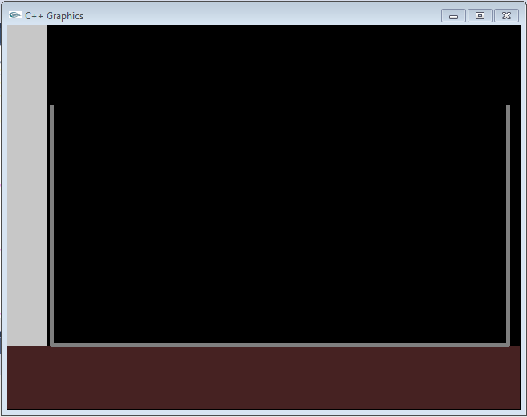
Write a C++ program that implements the drawing of a cross-section of a cylindrical container (the class is named Container) that consists of a variable height, radius and color. This Container class will be used in lab7out to complete a simulation of a fluid flowing from a faucet into this Container. This lab7in will only be responsible for drawing the container. An example of a grey Container (Color is 128, 128,128) with a radius of 285 and a height of 300 drawn in the Graphics Window is shown below:
Width of region is 55
Height of region is 400
Color of region is 200,200,200

pos – upper left coordinate of Container

Concrete wall

Width of region is 640
Height of region is 80
Color of region is 71,35,35
Cross-Section of Container

Line width of Container is 5.

Ground

Ground
Another example of a yellow container with a radius of 50 with a height of 100 is shown below:
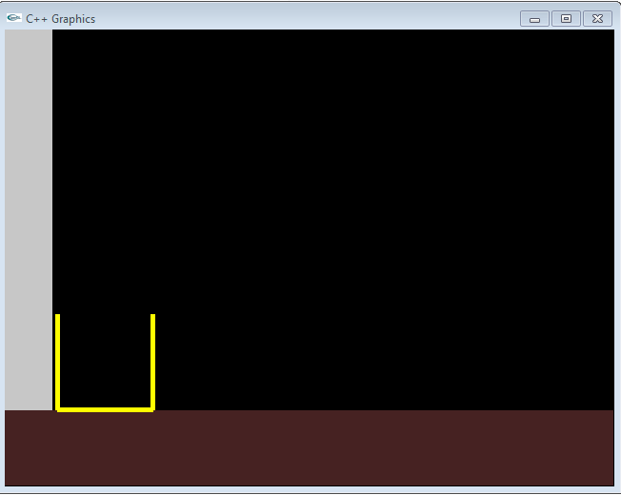

Another example for a cylinder with a radius of 175, a height of 200 and a color of 80, 80, 80 is shown below:
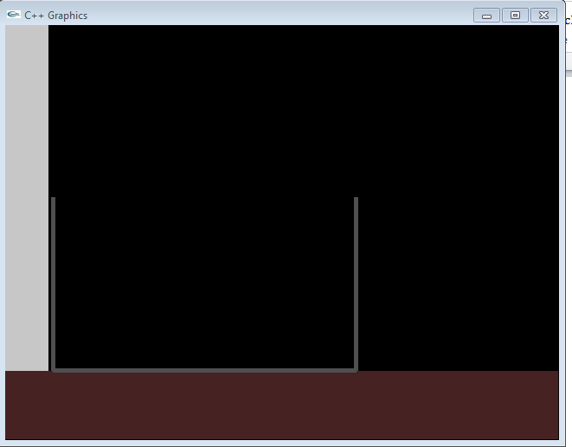

The prompting for the information will be done in main as shown below:
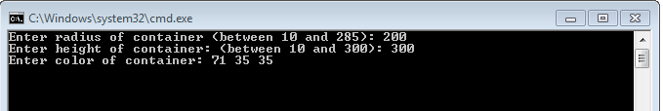

Note the grey region to the left – it represents a concrete wall while the brown area at the bottom represents the ground. The Container class is declared below as follows:

#ifndef CONTAINER_H
#define CONTAINER_H

#include "GenPoint.h"
#include "Color.h"

class Container
{
private:
GenPoint pos;
int radius;
int height;
Color color;

public:
Container();
void setPosition(GenPoint pos);
void setRadius(int radius);
void setHeight(int height);
void setColor(Color color);
GenPoint getPosition();
int getRadius();
int getHeight();
Color getColor();
void draw();

};

#endif

A full description of the Container’s data fields and methods are given below in the Class Section. Notice that the Container class contains 2 other classes – GenPoint and Color. The GenPoint class is declared below as follows:

#ifndef GENPOINT_H
#define GENPOINT_H

class GenPoint
{
private:
int x;
int y;

public:
GenPoint();
GenPoint(int x, int y);
void setPoint(int x, int y);
int getX();
int getY();
};

#endif

A full description of the GenPoint’s data fields and methods are given below in the Class Description section.

The Color class declaration is given below:

#ifndef COLOR_H
#define COLOR_H

class Color
{
private:
int r;
int g;
int b;

public:
Color();
Color(int r, int g, int b);
void setColor(int r, int g, int b);
int getRed();
int getGreen();
int getBlue();

};

#endif

A full description of the Color’s data fields and methods are given below in the Class Description section.

The Container must should be contained within the Simulation class. The purpose of the simulation for this lab is to just draw the Container. But the Simulation class will be extended in the lab7out to include the actual flowing of a fluid from a Faucet into the Container. The simulation will perform the following within its draw method:

- Draw the Concrete Wall (region at far left) and Ground (region at bottom). This step should be performed within the draw method of the Simulation class.
- Draw the Container This step should be performed within the draw method of the Simulation class.

The declaration for the Simulation class is given below:
#ifndef SIMULATION_H
#define SIMULATION_H

#include "Container.h"

class Simulation
{
private:
Container container;

public:
Simulation();
void setContainer(Container container);
Container getContainer();
void draw();
};

#endif

A complete description for the Simulation class is given in the Class Description section below.

Class Description

GenPoint

Data Fields

int x; //X-Coordinate of the point – valid values between 0 and 639
int y; //Y-Coordinate of the point – valid values between 0 and 479

Methods

GenPoint();
Default Constructor – initializes x/y private data fields to 0

GenPoint(int x, int y);
Parameterized Constructor – initializes x/y data fields to the input parameters x and y.

void setPoint(int x, int y);
Setter for x/y data fields.

int getX();
Getter for x.

int getY();
Getter for y.

Color

Data Fields

int r; //Red component of color – valid values between 0 and 255
int g; //Green component of color – valid values between 0 and 255
int b; //Blue component of color – valid values between 0 and 255

Methods

Color();
Default Constructor – sets all data fields to 0.

Color(int r, int g, int b);
Parameterized Constructor – sets data fields to the corresponding input parameters.

void setColor(int r, int g, int b);
Setter for all private data fields.

int getRed();
Getter for Red data field

int getGreen();
Getter for Green data field

int getBlue();
Getter for Blue data field

Container

Data Fields

GenPoint pos;
Upper left position of the Container as shown on page 1.

int radius;
Radius of the container

int height;
Height of the container

Color color;
Color of the Container

Methods

Container();
Default Constructor – sets all data fields to 0.

void setPosition(GenPoint pos);
Setter for the upper left position of the Container

void setRadius(int radius);
Setter for the radius of the Container

void setHeight(int height);
Setter for the height of Container

void setColor(Color color);
Setter for the Color of the Container

GenPoint getPosition();
Getter for the upper left position of the Container

int getRadius();
Getter for the radius

int getHeight();
Getter for the height

Color getColor();
Getter for the Color

void draw();
Draws the Container based on the upper left position indicated by pos, the radius, and the height.

Simulation

Data Fields

Container container;
Container object

Methods

Simulation();
Default Constructor – sets the Container data fields to 0

void setContainer(Container container);
Setter for Container

Container getContainer();
Getter for Container
void draw();
Draws the Concrete Wall, the Ground and the Container

Template for GenPoint Class:

#include <iostream>
#include "graph1.h"
#include "GenPoint.h"

GenPoint::GenPoint()
{

}

GenPoint::GenPoint(int x, int y)
{

}
void GenPoint::setPoint(int x, int y)
{

}
int GenPoint::getX()
{

}
int GenPoint::getY()
{

}

Template for Color Class

#include <iostream>
#include <cmath>
#include "Color.h"
#include "graph1.h"

Color::Color()
{

}

Color::Color(int r, int g, int b)
{

}

void Color::setColor(int r, int g, int b)
{

}

int Color::getRed()
{
}

int Color::getGreen()
{

}

int Color::getBlue()
{

}

Template for Container Class

#include <iostream>
#include <cmath>
#include "graph1.h"
#include "Container.h"

Container::Container()
{

}

void Container::setPosition(GenPoint pos)
{

}

void Container::setRadius(int radius)
{

}

void Container::setHeight(int height)
{

}

void Container::setColor(Color color)
{

}

GenPoint Container::getPosition()
{

}

int Container::getRadius()
{

}

int Container::getHeight()
{

}

Color Container::getColor()
{

}

void Container::draw()
{

}

Template for Simulation Class

#include <iostream>
#include "graph1.h"
#include "Simulation.h"

using namespace std;

Simulation::Simulation()
{

}

void Simulation::draw()
{

}

void Simulation::setContainer(Container container)
{
}

Container Simulation::getContainer()
{

}

Guidelines for main

Main should prompt for the radius, height and color of the Container and then build the Container based on this input. An example template for main is given below:

Template for main.cpp
#include <iostream>
#include "graph1.h"
#include "Simulation.h"

using namespace std;

int main()
{
//Variable Declaration/Initialization
int height = 0;
int radius = 0;
int r = 0;
int b = 0;
int g = 0;
char repeat;
Container container;
Simulation simulation;

//Display the graphics
displayGraphics();

//Continually simulate

do
{
//Get the Container's radius/height/color (Add Data Validation)

//Set the Containers radius/height /color
//Compute the Container upper left coordinate based on the height
//Set the Container’s position
//Hint: 55, 400 - height

//Set the Container for the Simulation

//Draw the simulation/container (invoke draw on Simulation)

//Repeat the simulation?
cout << "Repeat the simulation (y/n)? ";
cin >> repeat;

clearGraphics();
system("cls");

}while(repeat == 'y');

return 0;
}

.

What you Submit

Submit Container.h, Container.cpp, GenPoint.h, GenPoint.cpp, Color.h, Color.cpp, Simulation.h, Simulation.cpp, main.cpp (you can zip all of these up) via Blackboard.

